Quiz Final Exam BUS603-31

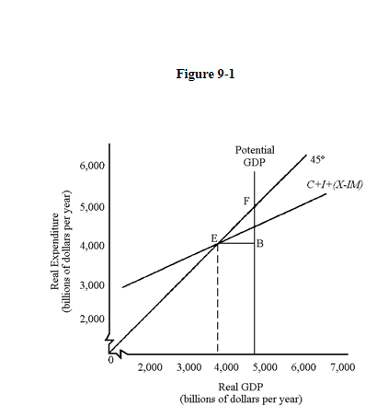
1. In Figure 9-1,

a. to the left of equilibrium GDP, inventories will fall.
b. to the right of equilibrium GDP, inventories will rise.
c. All of the above are correct.
d. the 45-degree line represents all points where spending equals output.

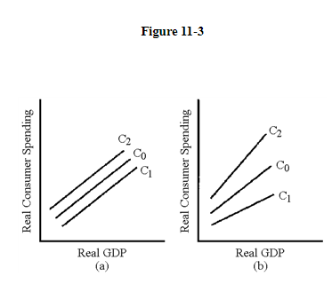
2. Of the graphs in Figure 19-3, where the dotted line shows the actual exchange rate, which one shows a country with an overvalued currency and a balance of trade deficit?

a. 4
b. 2
c. 3
d. 1

3. In Figure 11-3, which line represents the change in the consumption schedule caused by an increase in the personal income tax?

a. C1 in graph (a)
b. C2 in graph (a)
c. C2 in graph (b)
d. C1 in graph (b)

4. If wages rise by 12 percent at the same time prices rise by 3 percent, then the increase in real wages is equal to

a. 9 percent.
b. 6 percent.
c. 3 percent.
d. 12 percent.

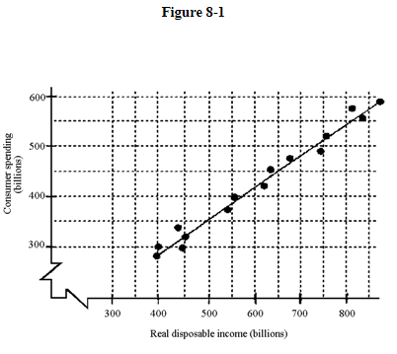
5. Based on the scatter diagram in Figure 8-1, approximately how much will consumption increase after a permanent tax cut of $400 billion?

a. $100 billion
b. $350 billion
c. $150 billion
d. $250 billion

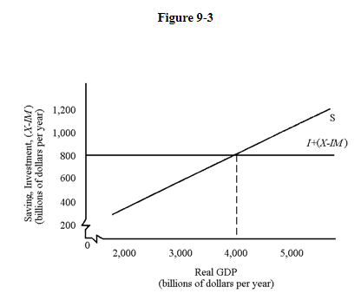
6. In Figure 9-3, equilibrium GDP is

a. $2,000 billion.
b. $3,000 billion.
c. $5,000 billion.
d. $4,000 billion.

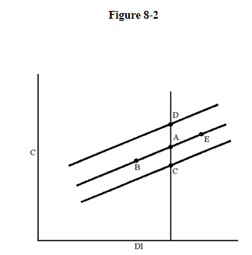

7. In Figure 8-2, which of the following moves can be explained by a tax cut?

a. A to C
b. A to D
c. A to E
d. A to B

8. Because of a recession in Japan, net exports from the United States decrease by $10 billion. If the MPC is 0.75, how much less spending will occur in the U.S. economy in the second "round" of spending?

a. $10 billion
b. $17.5 billion
c. $7.5 billion
d. $5.0 billion

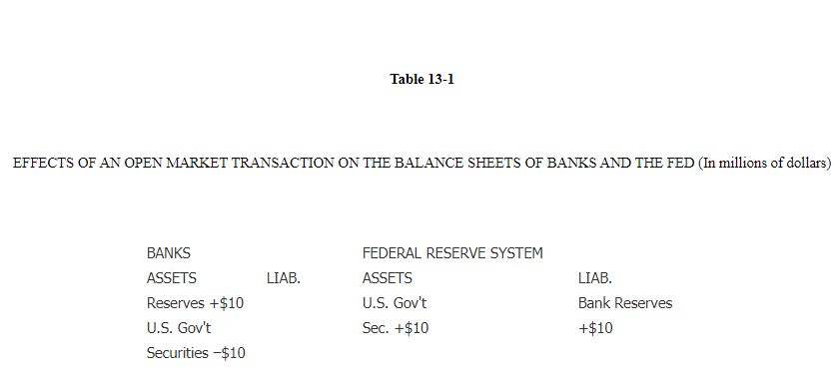
9. In Table 13-1, if the required reserve ratio is 10 percent, what will happen to the money supply? Use the oversimplified money multiplier in your calculations.

a. The money supply will decrease by $10 million.
b. The money supply will increase by $100 million.
c. The money supply will not change.
d. The money supply will increase by $10 million.
e. The money supply will decrease by $100 million.

10. The banking system receives a new cash deposit of $250,000. Total deposits eventually rise by $1 million. The value of the reserve ratio is

a. 0.20.
b. 0.50.
c. 25.
d. 0.25.
e. 4.

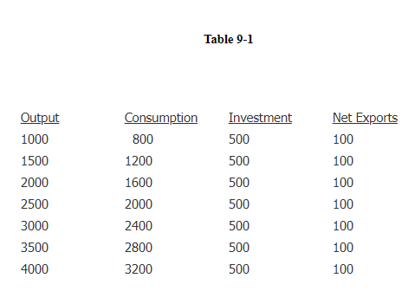
11. In Table 9-1, the equilibrium level of output is

a. 2,500.
b. 3,500.
c. 4,000.
d. 3,000.

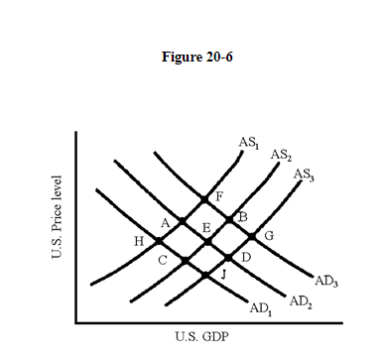
12. In Figure 20-6, an expansive fiscal policy in a closed economy results in an equilibrium at point E. In an open economy, allowing for the effects of the induced change in the currency value, the final equilibrium would be point

a. H.
b. J.
c. B.
d. F

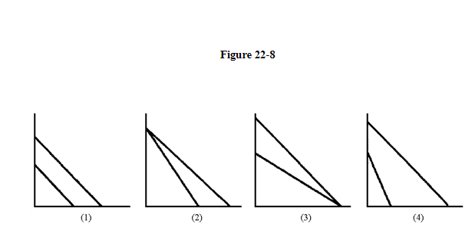
13. Figure 22-8 has four sets of production possibility curves for two hypothetical countries. In which case will there be no advantage to trade between the two countries?

a. 1
b. 2
c. 4
d. 3

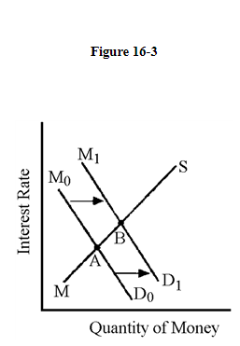
14. If budget deficits shift the money demand curve as is illustrated in Figure 16-3, which component of total expenditures will be affected the most?

a. consumption spending
b. government spending
c. net exports
d. private investment spending

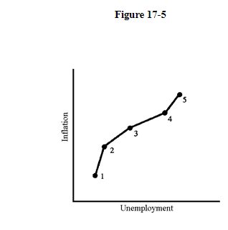
15. The data illustrated in Figure 17-5 would be most representative of which decade?

a. the 1970s
b. the 1980s
c. the 1960s
d. the 1990s

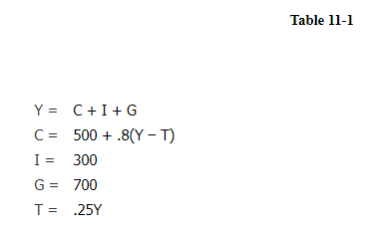
16. Refer to Table 11-1. What is the level of consumption in this model?

a. 2,750
b. 2,350
c. 2,150
d. 2,550
e. 2,950

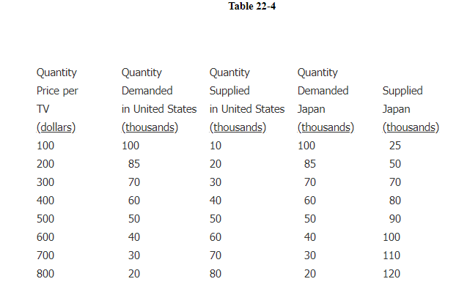
17. Table 22-4 presents the demand and supply schedules for television sets in Japan and the United States. If Japan and the United States trade with each other, what will be the equilibrium price in the world market for television sets?

a. $200
b. $100
c. $400
d. $300

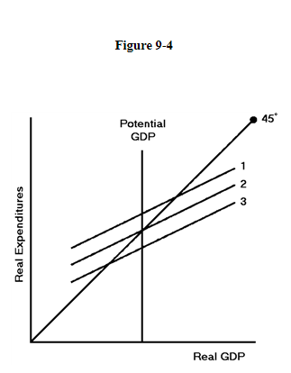
18. In Figure 9-4, if the economy is in a recessionary gap, what must happen to reach potential GDP?

a. The expenditure level must rise and/or the price level must fall.
b. The expenditure level must fall and /or the price level must fall.
c. The expenditure level must fall and/or the price level must rise.
d. The expenditure level must rise and/or the price level must rise.

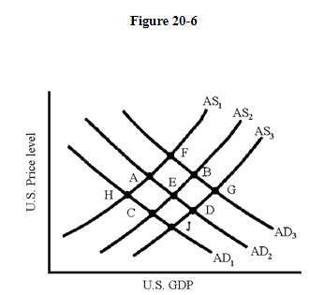
19. In Figure 20-6, which of the following will cause a movement from equilibrium at point A to equilibrium at point C?

a. an increase in the U.S. price level
b. a depreciation of the dollar
c. an appreciation of the dollar
d. an appreciation of the Japanese yen

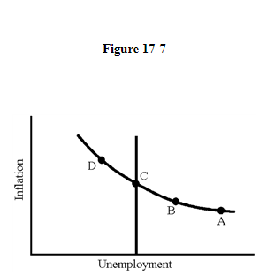
20. In Figure 17-7, the only sustainable long-run equilibrium position is at point

a. C.
b. B.
c. D.
d. A.

21. The nation's disposable income increases by $400 billion and, as a result, consumer spending increases by $320 billion. Therefore, the MPC equals

a. 0.20.
b. 0.60.
c. 0.80.
d. 0.16.
e. 0.96.

Aggregate demand and supply curves have been widely used to analyze the performance of the macroeconomy. Figure 5-3 shows four diagrams that represent different changes in the macroeconomy. Choose the diagram that best represents the situations described in the following questions.

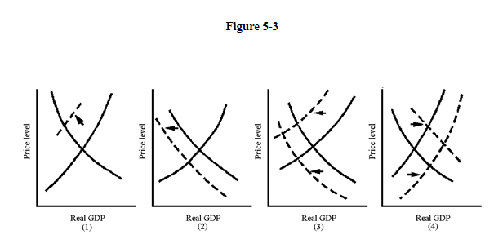
22. Which graph in Figure 5-3 best represents the favorable macroeconomy of the late 1990s?

a. 1
b. 2
c. 3
d. 4

23. If a 10-year Treasury bond pays 1.5% and a 10-year corporate bond pays 6.0%, what is the interest rate spread on this particular corporate bond?

a. 4.0%
b. 4.5%
c. 9.0%
d. 7.5%

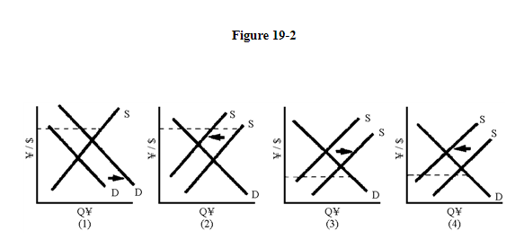
24. Of the graphs in Figure 19-2, where the broken line represents the fixed exchange rate, which one shows a reduction in the price level in Japan that would reduce a balance of payments deficit?

a. 2
b. 1
c. 4
d. 3

25. If you purchased shares of common stock in 1990 for $1,000 and sold them for $2,000 in 2001 you would be liable for taxes on

a. $1,000 less the rate of inflation.
b. $2,000 less the rate of inflation.
c. $2,000.
d. $1,000.

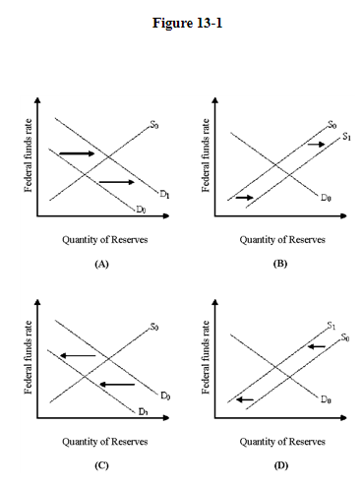
26. In Figure 13-1, which panel shows the effect of inflation on the interest rate?

a. Panel (D)
b. Panel (C)
c. Panel (A)
d. Panel (B)

27. Suppose that with 1 unit of labor, Canada can produce 40 TVs or 20 computers. With 1 unit of labor, Taiwan can produce 30 TVs or 10 computers. Which of the following is correct?

a. Taiwan has an absolute advantage in the production of computers.
b. Canada has an absolute advantage in the production of neither good.
c. Canada has a comparative advantage in the production of computers.
d. Taiwan has an absolute advantage in the production of TVs.
e. Taiwan has a comparative advantage in the production of computers.

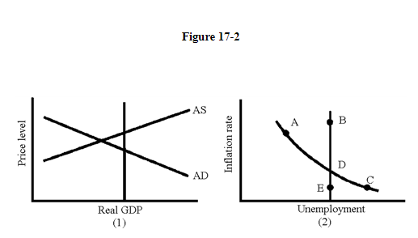
28. Given the situation in graph (1) in Figure 17-2, what action could be expected from the economy's self-correcting mechanism?

a. a decrease in aggregate supply
b. an increase in aggregate demand
c. an increase in aggregate supply
d. a decrease in aggregate demand

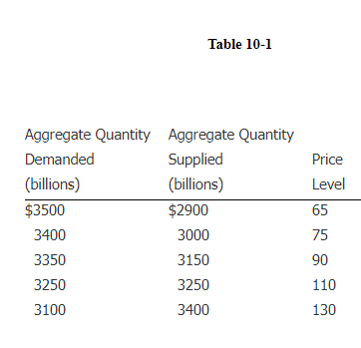
29. In Table 10-1, if full employment occurs at $3,400 billion, then

a. the economy experiences a recessionary gap of $150 billion.
b. the economy experiences an inflationary gap of $150 billion.
c. the economy experiences an inflationary gap of $75 billion.
d. the economy experiences a recessionary gap of $75 billion.

30. Sharon buys some common stock in 1990 for $10,000 and sells it in 2000 for $15,000. During the same period, prices have risen by 75 percent. The net result of Sharon's stock purchases is that she will

a. earn a real capital gain of $15,000 minus 75 percent.
b. earn a real capital gain of $5,000 plus 75 percent.
c. lose purchasing power and have to pay taxes anyway.
d. pay no taxes because she earned negative real capital gains.

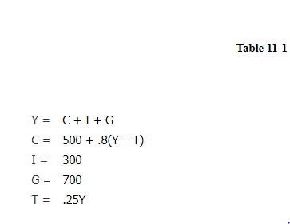
31. Refer to Table 11-1. What is the equilibrium level of income in this model?

a. 3,750
b. 4,500
c. 5,000
d. 3,500
e. 3,250

32. Aneta has owned an Italian sports car for several years and now she wants to sell it. She paid $8,500 for it in 1993 and she has just sold it for $39,000 in 2015. How is this sale included in the GDP for 2015?

a. $39,000 is included in 2015 GDP
b. $8,500 is included in 2015 GDP
c. The increase in value of $10,500 is included in 2015 GDP
d. It is not included in 2015 GDP

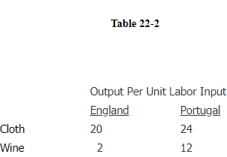
33. Using the data from Table 22-2, suppose England transfers 2 units of labor from wine to cloth and Portugal transfers 1 unit from cloth to wine. The combined production of wine and cloth will be increased by

a. 16 wine, 8 cloth.
b. 16 wine, 16 cloth.
c. 8 wine, 16 cloth.
d. 12 wine, 12 cloth.

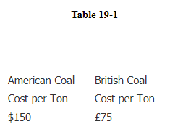
34. Assume that the information in Table 19-1 applies to the cost per ton of coal in 1998. Assume that also over a 10-year period prices rise 100 percent in Great Britain and 200 percent in the United States. According to the purchasing power parity theory, the exchange rate between the dollar and the pound in the year 2008 will be

a. one pound = two dollars.
b. one pound = three dollars.
c. one dollar = three pounds.
d. one dollar = two pounds.
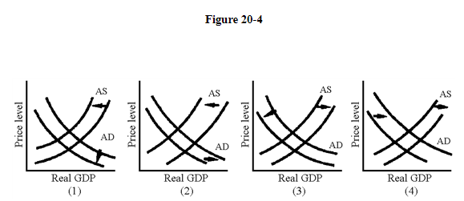

35. Which of the situations illustrated in Figure 20-4 shows a currency depreciation leading to inflation?

a. 4
b. 1
c. 3
d. 2

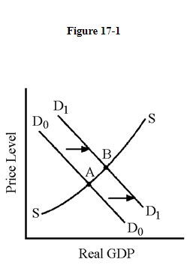
36. Which of the following is true about the economy depicted in Figure 17-1?

a. Policy makers believe the costs of unemployment are higher than the costs of inflation.
b. Tax incentives are being used to stimulate aggregate supply.
c. Prices are rising but real GDP is falling.
d. Contractionary monetary policy is being enacted to fight inflation.

37. If the multiplier is 4 and real GDP increases by $520 billion, the increase in investment spending must have been

a. $120 billion.
b. $110 billion.
c. $140 billion.
d. $130 billion.

38. If the exchange rate of the Swiss franc is 1.61 francs per dollar, then the Swiss franc is worth about

a. 57 cents
b. $15.70.
c. 62 cents.
d. 15 cents.

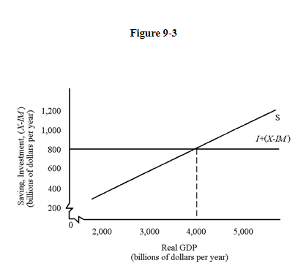
39. In Figure 9-3, investment plus net exports equals

a. $600 billion.
b. $800 billion.
c. $1,200 billion.
d. $200 billion.
e. $400 billion.

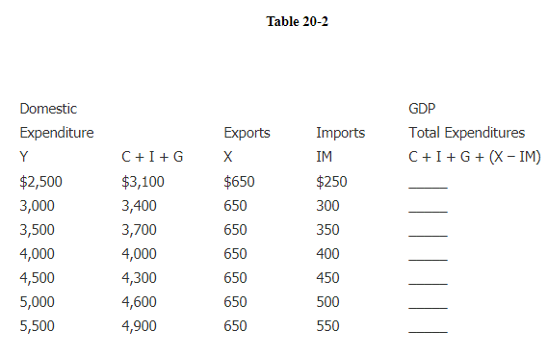
40. In Table 20-2, what are net exports when GDP = 3,500?

a. 200
b. 400
c. 300
d. 100

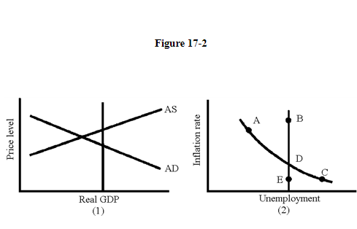
41. Given the situation in graph (1) in Figure 17-2, what movement would be expected in graph (2) from the economy's self-correcting mechanism?

a. C to E
b. D to C
c. A to B
d. A to D

42. If businesses spend an additional $150 billion for investment projects in 2010, what will be the impact on national income (Y) if the multiplier is 2?

a. Y will increase by $300 billion.
b. Y will increase by $50 billion.
c. Y will increase by $450 billion.
d. Y will increase by $150 billion.

43. In an open economy, the government deficit is 400 and investment exceeds saving by 300, so in equilibrium the trade deficit (IM − X) must be

a. 200.
b. 100.
c. 700.
d. 300.

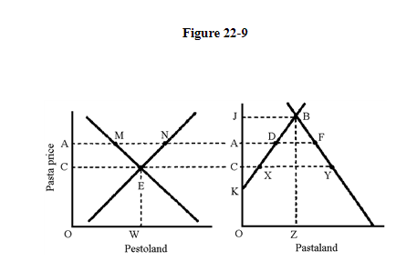
44. In Figure 22-9, at price OC

a. quantity supplied of pasta exceeds quantity demanded so price will fall.
b. imports of pasta equal XY.
c. exports of pasta equal XY.
d. quantity demanded for pasta exceeds quantity supplied so price will rise.

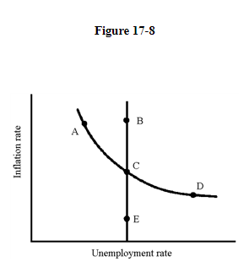
45. In Figure 17-8, which of the following movements reflects the Fed's anti-inflationary policy of the early 1980s and the following market adjustment?

a. A to B to C
b. E to A to B
c. C to D to E
d. D to E to C

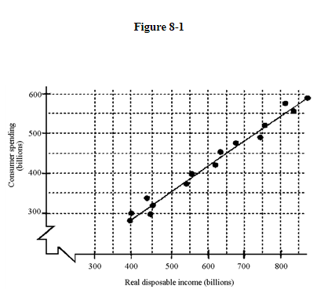
46. Given the scatter diagram in Figure 8-1, what is the MPC (your best estimate)?

a. 2/3
b. 1/2
c. 1/3
d. 1

47. Assume that the MPC is 0.85 and investment spending rises by $100 million. How much consumption spending will this generate in the second round of spending?

a. $15 million
b. $118 million
c. $185 million
d. $100 million
e. $85 million

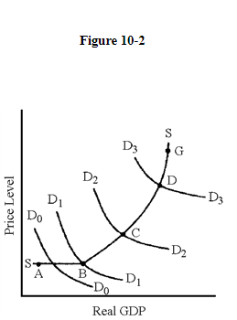
48. In Figure 10-2, which segment of the aggregate supply curve has the smallest multiplier effect?

a. DG
b. CD
c. AB
d. BC

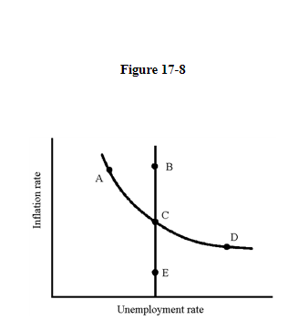
49. In Figure 17-8, which of the following movements reflects the closing of an inflationary gap through the economy's automatic adjustment mechanism?

a. C to E
b. A to B
c. A to C
d. D to E

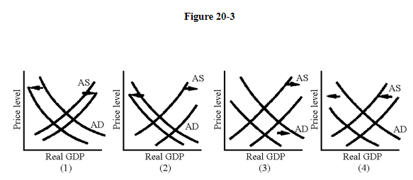
50. Which of the situations illustrated in Figure 20-3 shows the effects of a currency appreciation leading to a recession?

a. 4
b. 1
c. 3
d. 2

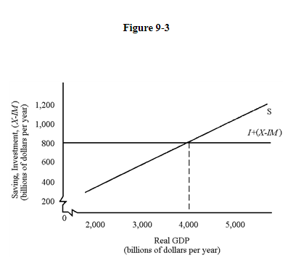
51. In Figure 9-3, at $5,000 billion GDP, inventories will be

a. accumulating, signaling businesses to increase production.
b. accumulating, signaling businesses to cut production.
c. falling, signaling businesses to increase production.
d. falling, signaling businesses to cut production.

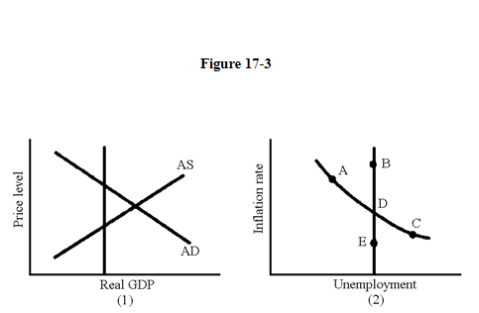
52. Given the situation in graph (1) in Figure 17-3, what can be expected to change in graph (1) when the economy's self-correcting mechanism operates?

a. aggregate demand increases
b. aggregate supply increases
c. aggregate supply decreases
d. aggregate demand decreases

53. On May 12, 2011, the U.S. dollar was worth 0.61 British pounds. How many dollars did it take to buy one British pound?

a. 1.64
b. 1.61
c. 1.19
d. 2.19

54. The president wishes to increase spending for education by $4 billion but also maintain a balanced budget. Therefore, taxes will also be increased by $4 billion. What will happen to GDP?

a. It will increase.
b. It will decrease.
c. It's impossible to know without the multiplier.
d. It will remain the same.

55. When a banker accepts a deposit of $1,000 in cash and puts $200 aside as required reserves and then makes a loan of $800 to a new borrower, this set of transactions

a. does not change the money supply.
b. increases the money supply by $800.
c. increases the money supply by $200.
d. decreases the money supply by $200.
e. decreases the money supply by $1,000.

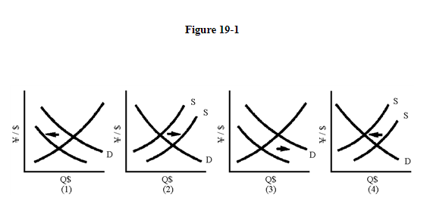
56. Of the graphs in Figure 19-1, which one shows that an expansion of the Japanese economy leads to a depreciation of the yen?

a. 2
b. 3
c. 1
d. 4

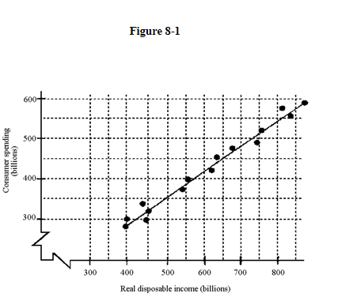
57. Given the scatter diagram in Figure 8-1, how much will consumption decrease if the price level rises by 5 percent?

a. cannot be determined
b. $100 billion
c. $50 billion
d. $200 billion

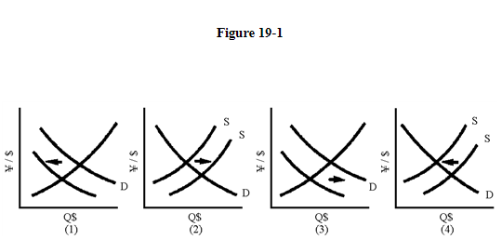
58. Of the graphs in Figure 19-1, which one shows the effects of an increase in interest rates in Japan and a depreciation of the dollar?

a. 1
b. 4
c. 2
d. 3

59. If nominal GDP is $7,700 billion and M1 is $1,000 billion, then velocity is

a. 7.0.
b. 7.7.
c. 10.7.
d. 7.1.

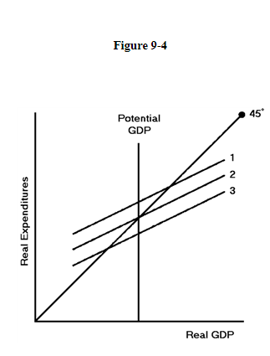
60. In Figure 9-4, if the economy faces an inflationary gap, what must happen to reach potential GDP?

a. The expenditure level must rise and/or the price level must rise.
b. The expenditure level must fall and/or the price level must rise.
c. The expenditure level must rise and/or the price level must fall.
d. The expenditure level must fall and/or the price level must fall.

